

Banking Management system

END TERM PROJECT REPORT



BY

AKSHAT JAIN (44)

ARVINDER KAUR (45)

SHUBHAM KALIHARI (46)



Department of Intelligent Systems

School of Computer Science Engineering

Lovely Professional University, Jalandhar

MARCH-2018

**Student Declaration**

This is to declare that this report has been written by us. No part of the report is copied from other sources. All information included from other sources have been duly acknowledged. We aver that if any part of the report is found to be copied, we are shall take full responsibility for it.

AKSHAT JAIN

ROLL NUMBER-44

REG. NO-11712846

ARVINDER KAUR

ROLL NUMBER-45

REG. NO-11710057

SHUBHAM KALIHARI

ROLL NUMBER-44

REG. NO-11712846

Place : Lovely Professional University, Jalandhar, Punjab

Date : 2/03/2018

**TABLE OF CONTENT**

**TITLE PAGE NO.**

1. **Background and the objective of the project 1**
   1. **Motivation and outcomes 1**
   2. **Project objective 2**
   3. **Project scope 2**
2. **Description of the Project**

**2.1 Looks and design 3**

**2.2 Flow Diagram 4**

**2.3 Progress of the Project 5**

**2.4 Work Division 5**

**2.5 Technology and Framework used 5**

**2.6 SWOT Analysis 5**

BONAFIDE CERTIFICATE

Certified that this project report “BANKING MANAGEMENT SYSTEM” is the bonafide work of Akshat Jain, Arvinder Kaur and Shubham Kalihari who carried out the project work under my supervision.

**Ranjit Kaur**

**Assistant Professor**

# Background and objective of the project.

**Motivation and outcome:-**

The Traditional way of maintaining details of a user in a bank was to enter the details and record them. Every time the user need to perform some transactions he has to go to bank and perform the necessary actions, which may not be so easy all the time. It may be a hard task for the users and the bankers too.

Objective of our project “Banking Management System” is to organize the information of the customers online and to provide them a facility of doing transaction online, it will also help bank by managing accounts, transaction information, account summary and many more.

Online Banking System provides is specifically developed for online banking for Balance Enquiry, Funds Transfer to another account in the same bank, Loan details, Request for cheque book/ change of address/ stop payment of cheques, Mini statements

Nowadays, people have to stand hours in the que for their works to be done, they have to spend their precious time even for a two minutes work, but instead of wasting their resources if they chose online banking it will save their time and money, they simply have to login into their accounts and can do their work.

It will also convenient for the people, because they can access to their bank account from anywhere, there is not any particular place for accessing their account. The site will be available 24*7 to the customers.

Traditionally staff of the Banks have to work hard for managing the accounts information. Our project will help them to reduce their manual work, the information entered by the customers will directly save to the servers.

Our project will also decrease the probability of errors, previously the lot of manual always lead to the error which affect the customers as well as bank also, but after implementation of our project most of the work is done by the computers and servers so percentage of error will decrease, also error rectification will become easy, it will be easy to find the error within minutes instead of searching each and every file.

Here, we provide an automation for banking system through Internet. Online Banking System project captures activities performed by different roles in real life banking which provides further improved techniques for maintaining the required information up to- date, which results in efficiency.

Now in short we can say that:-

**Project objective:-**

* To allow only authorized user to access various function and processed available in the system.
* Locate any account wanted by the user.
* Reduce manual work as most of the work is done by the computer.
* Provide greater speed and reduce time consumption.

**Project scope:-**

Banking activities are considered to be the most important for countries economy. Without banking activities trade and other activities which have transactions, cannot work smoothly.

Banks are the distributer and the protector of the capital efficient administration of the banking system helps in the economic growth of the nation. Banking is useful to trade and commerce.

Description of the project

**Looks and Design:-**

Our project is html based project, the first page will be description page, there will be information and caution related to the online banking safety, there will be an image in the background, and a bank logo on the side. There will be to hyperlinks one is for going to the login page and another is for going to sign up page. Those who already have an online banking account the can go to the login page and those who do not have any online banking account they have to create an account by going to signup page

Login page have two fields one is text field for entering username and another is a password field for entering password. It will also contain a button which when clicked will transfer to the bank account of the person who had logged in.

Sign up page will contain fields for entering first name, last name, account number, date of birth, radio buttons for gender(Male, Female, Other), check box for type of account, place where he or she lives etc. At last there will be a submit button which will create an online banking account of the customer.

When existing customer will log in he or she will be displayed the total available balance in his or her bank account. There will be the option for viewing last 10 transaction and to view the record for one month. Their will dropdown pf my account and profile where there will be option for account summary where he can get information about his account, branch info where he can get information of his branch and account statement which give statement of his account, a dropdown of payment and transfer where user can transfer money and a dropdown of credit and debit card information.

**Flow Diagram:-**

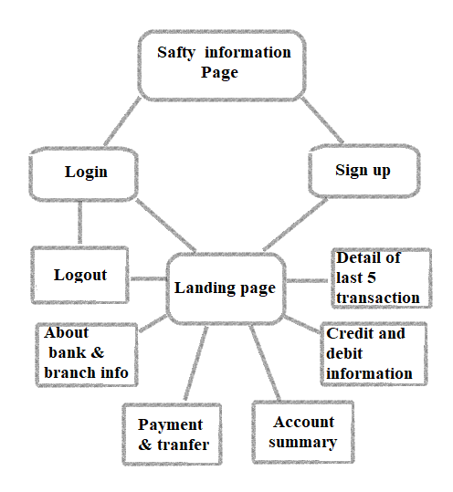

**Description of project in terms of work division:-**

Aakshat have designed account summary where user can get all the information about his/her account, payment and transfer page which contains the information about user’s all the payments and transfer he had done and credit and debit information page which contain information about your debit or credit cards, Arvinder have designed sign up page where any new user can create new online banking account, about bank where bank vision and moto is show and branch information where you can get information about the branches of bank, Shubham will design introduction and safety page where user can see some safety information, login page where user can enter his/her user name and login to the account , landing page where you can see details of last five transaction and contains link for going to different web page of the site.

**Implementation of scheduled work project:-**

SAFTY INFORMATION PAGE:- 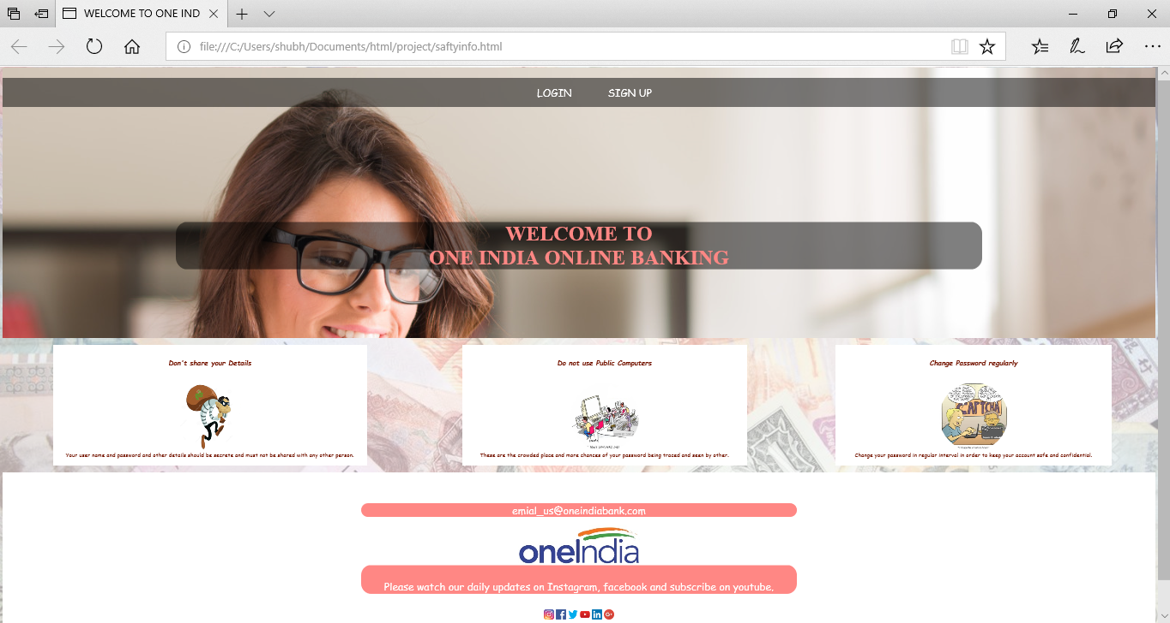

This is the first page of the website. When user open this page a popup alert will display showing message “WELCOME”. We have divided this page into 6 grid using 5 divisions. 1st division have 2 sub division in 1st sub division there are two links LOGIN and SIGNUP. If user click in LOGIN he will be directed to login page, if user click on SIGNUP he will be directed to signup page, when user put mouse pointer on these text, its color will change. In 2nd subdivision it is written “WELCOME TO ONE INDIA ONLINE BANKING”. In 3rd, 4th and 5th division there is safety related information with images and in 6th division the web page have banks email address and social media information.

LOGIN PAGE:-

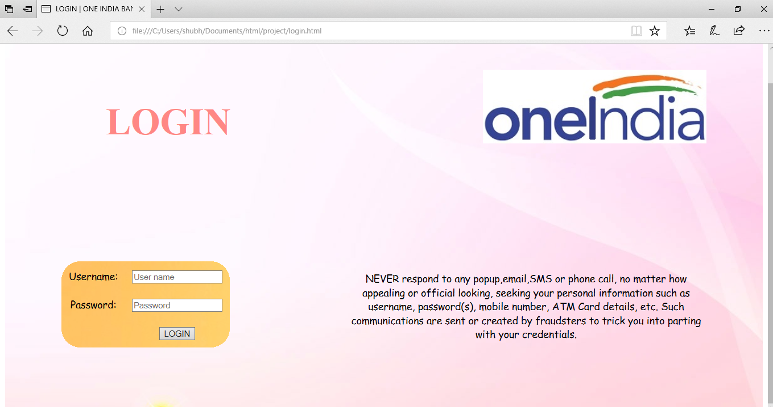

When user click on the LOGIN link in safety information page, then he will be directed to the log in page. First a pop will appear showing message “You are directed to login page”. Here also we have divided the whole web page into 4 grids using divisions. In 1st division it is written LOGIN in second division there is a bank logo, in 3rd division user have to input their username and password and their input will submit when the click on login button, when user focus on the text field or password field their color will change, when user click the login button a pop will come showing the message you are logging in. inside 4rt division there is some safety information.

SIGNUP PAGE:-

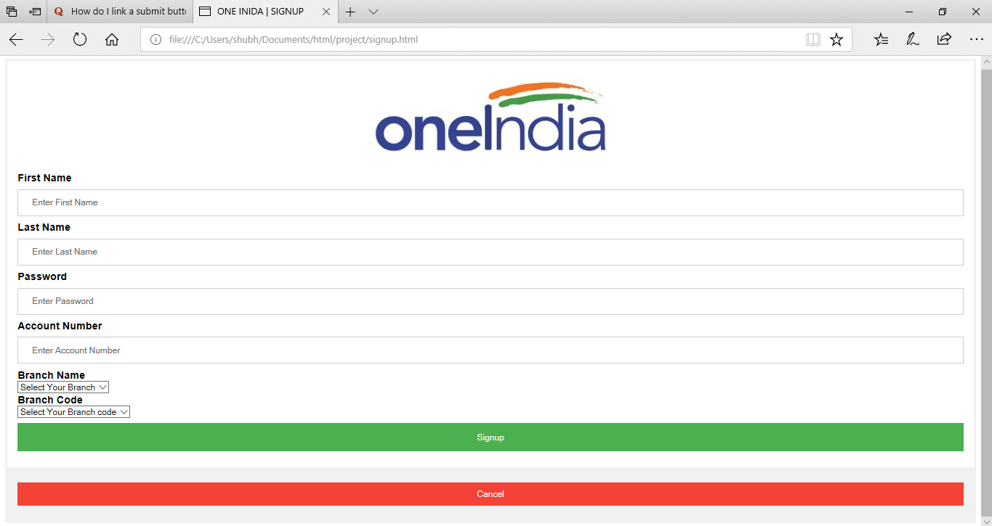

This is sign up page. When user will click SIGN UP link in Safety information page. First a popup will appear displaying message “Please fill all the details”, then user will input all his details like first name, last name, password, account number, branch name and branch code. When he/she click signup button he will be directed to landing page and if select cancel button, then directed to safety information page.

LANDING PAGE:-

This page will open when user will sign up or login. This page is also divided into grids using division. In 1st division there is a pic of the user and name, in 2nd division there is bank logo and a sub division containing links to about bank page, branch information page and logout, in 3rd division user can see account balance and can see link to go to payment and transfer page, account summary and credit and debit information page, in 4th division there is the record of his last 5 transaction, in 5th there is simple information and if user want to know total credit and debit amount it will be displayed here and 6th division there is simple information.

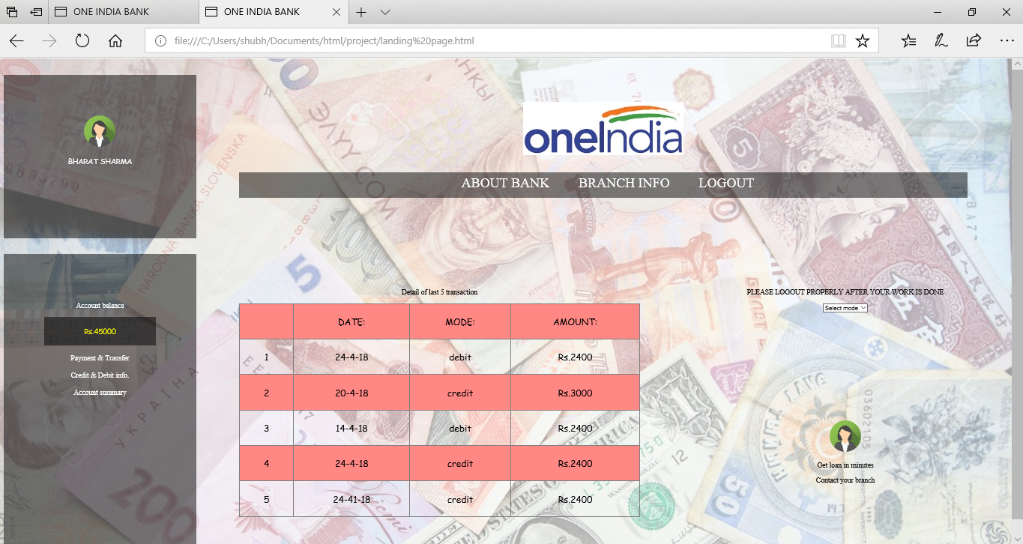

ABOUT BANK AND BRANCH INFORMATION:-

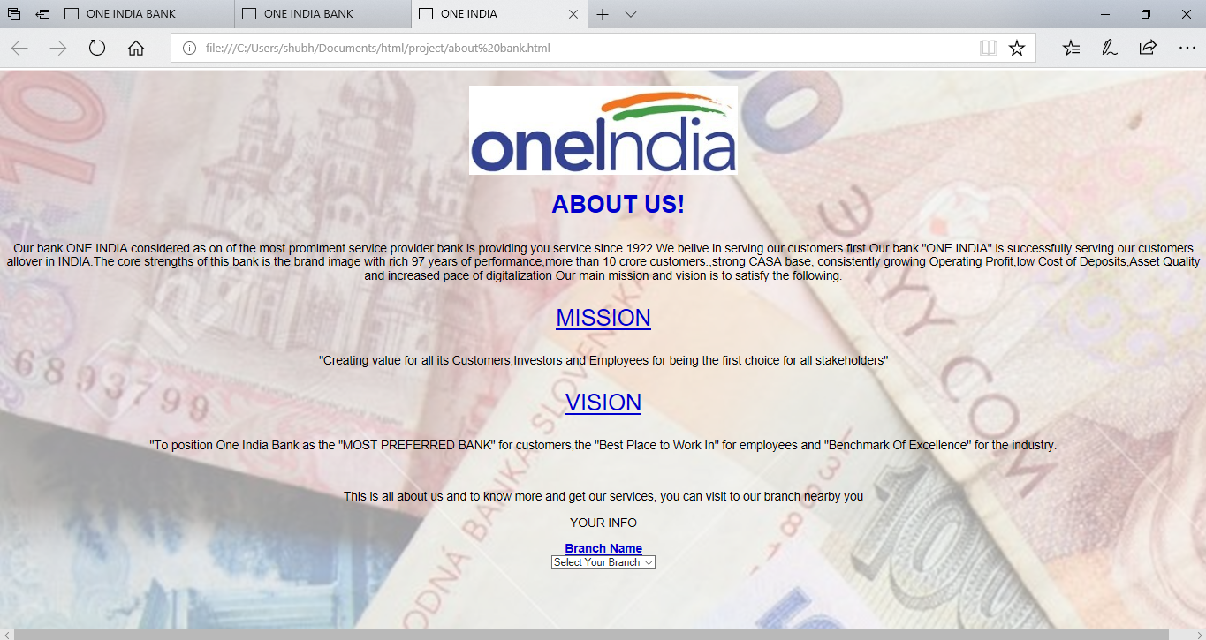

Here user can see information about bank, mission and vision and if user want to know about any branch there is a dropdown, user will select branch and information will be displayed below your info.

ACCOUNT SUMMARY:-

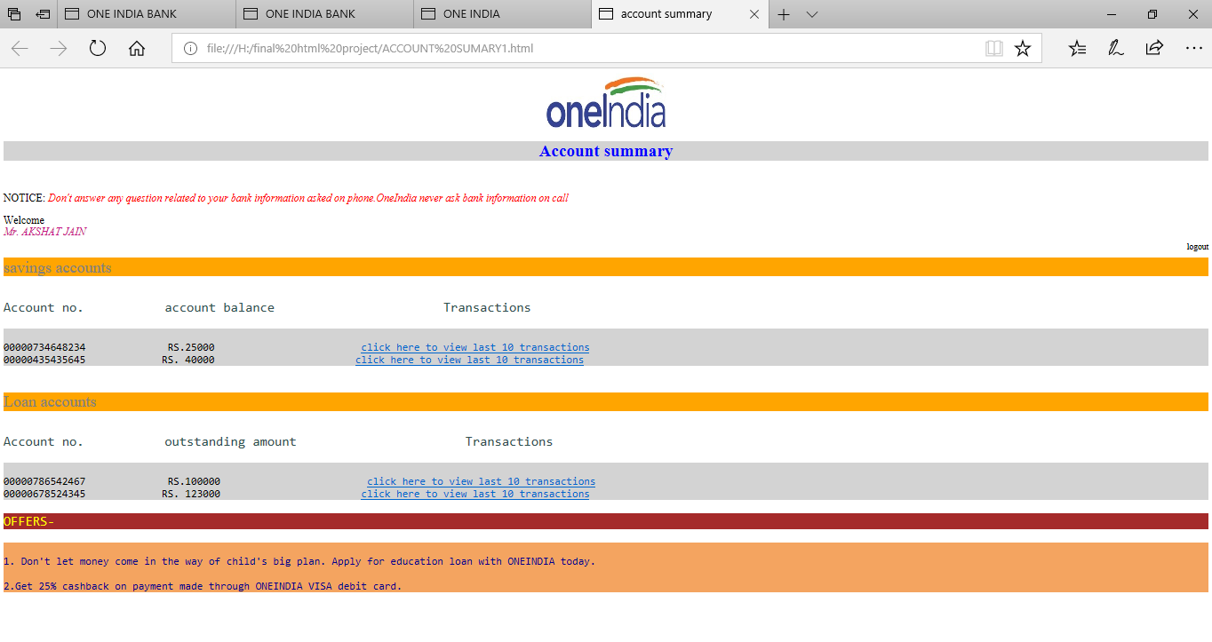

This page contains account summary of the user which includes types of accounts and their details including Account no, account balance/outstanding amount and Transactions. Though this page we want to summarize the whole account status.

CREDIT AND DEBIT INFORMATION:-

In this page you user can get information about his/her present credit and debit information, name of the card holder, card number, validity and type of card user have Rupay or Visa .

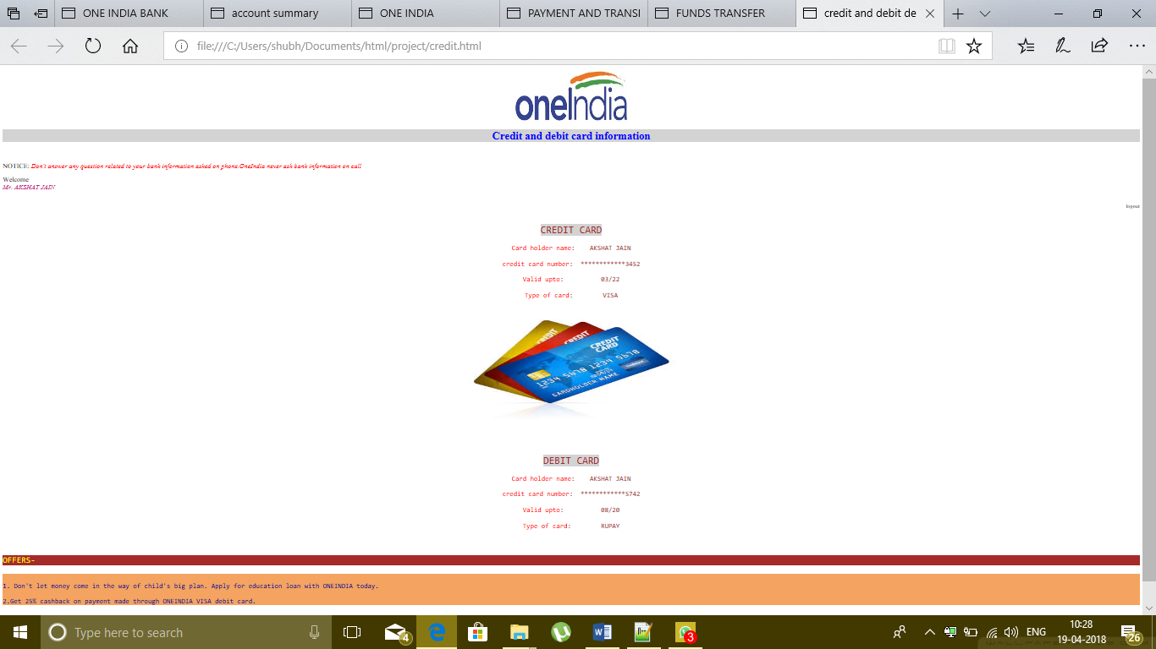

PAYMENT AND TRANSFER PAGE:-

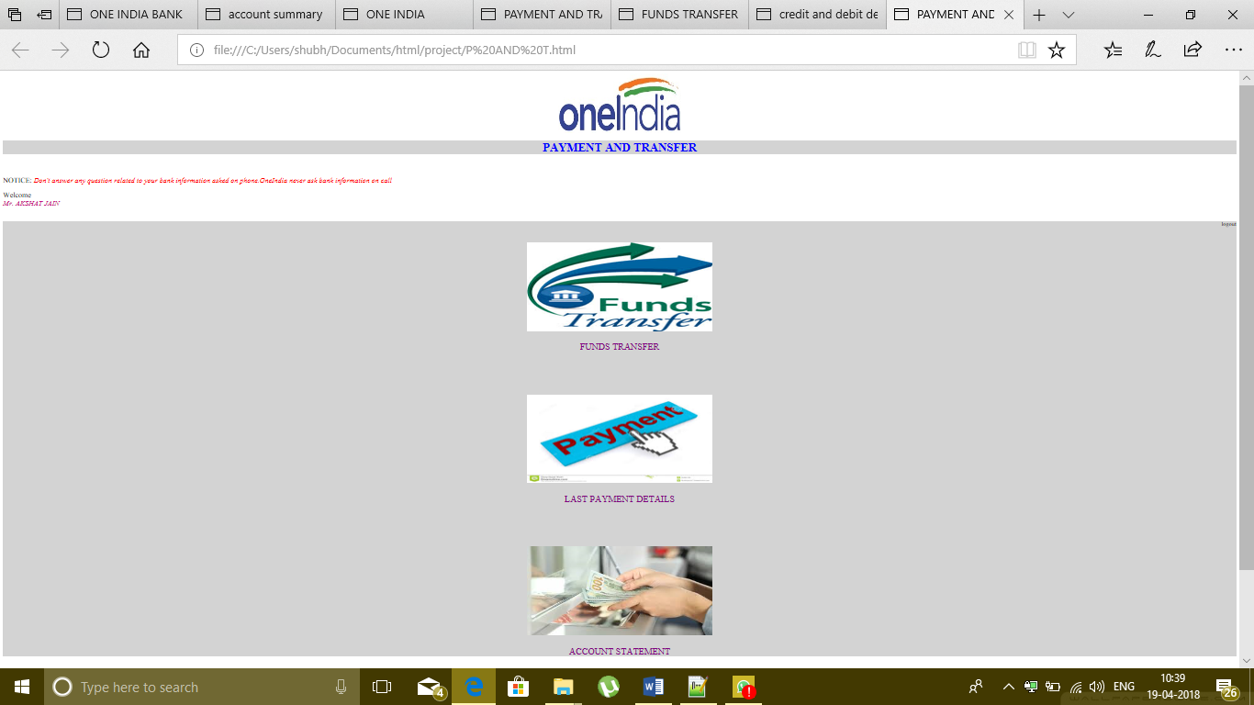

In this page we have made various options including funds transfer last payment details and account statement which will help the user to transfer the money and to know the payment details easily.

**Technology and framework used:-**

* HTML(Hyper Text Markup Language)
* CSS(Cascading Style Sheet)
* Java script

**SWOT Analysis:-**

**Strengths:-**

- Secure and convenient online banking for customers

- Quality product and friendly service

- Focused differentiation strategy

- Low cost structure due to no physical presence of branches

- Knowledgeable and friendly staff members

- Technology savvy and convenience minded customer target

- Serving customers efficiently, quickly and efficiently

- Partnership for brokerage accounts

- Web trust seal security

- High asset growth

- High deposit growth

- All product focused strategy

- Efficient cost structure

- 24 hours and 7 days call centers

- More convenient services by online account

**Weakness:-**

- No brand recognition

- Only 2 percent share of online market

- Requirement oh huge amount of investment

-Missing of personal human touch.

-Availability to poor people and people leaving in remote area.

-Need of expert staff to handle most of the banking operations.

-Technology availability is must before implementation of project.

-Continual wants of customers wants and needs

-Hostile feelings of employees due to possible pending layoffs due to automation

-Multiple option for the customers

**Opportunities:-**

-To provide User-Friendly and convenient banking services.

-To provide value added services.

-Reduction in cost and gain in efficiency.

-Faster flow of information.

-To develop data ware house for customer support services.

-Integration of eBanking services with eGovernance services.

-Wireless technological advancement and future scope.

-Mobile phone rapid sale.

-Improving infrastructure with cheaper DSL, satellite cell phones, roads,stc

**Threats:-**

-Shorter life of technology

-Lack of technical Expert staff

-Location Risk

-Legal risks

-Digital divide in society

-Supervisory risk.

-Continual need of upgradation.

-Security risk of Hacking System.